# DYNAMICS OF SUPPLY CHAIN MANAGEMENT

## 5.1 Push and Pull Mechanisms of Supply Chain Processes

Supply chain processes fall into one of two categories depending on the timing of their execution relative to customer demand

* **Pull:** execution is initiated in response to a customer order (reactive)
* **Push:** execution is initiated in anticipation of customer orders (speculative)

Push/pull boundary separates push processes from pull processes

Therefore, at the time of execution of a pull process, customer demand is known with certainty, whereas at the time of execution of a push process, demand is not known and must be forecast. Pull processes may also be referred to as reactive processes because they react to customer demand. Push processes may also be referred to as speculative processes because they respond to speculated (or forecasted) rather than actual demand. The push/pull boundary in a supply chain separates push processes from pull processes as shown in Figure 1 Push processes operate in an uncertain environment because customer demand is not yet known. Pull processes operate in an environment in which customer demand is known. They are, however, often constrained by inventory and capacity decisions that were made in the push phase.

Let us compare a make-to-stock environment like that of L.L.Bean and a build-toorder environment like that of Dell to compare the push/pull view and the cycle view. L.L.Bean executes all processes in the customer order cycle after the customer arrives. All processes that are part of the customer order cycle are thus pull processes. Order fulfillment takes place from product in inventory that is built up in anticipation of customer orders. The goal of the replenishment cycle is to ensure product availability when a customer order arrives. All processes in the replenishment cycle are performed in anticipation of demand and are thus push processes. The same holds true for processes in the manufacturing and procurement cycle. In fact, raw material such as fabric is often purchased six to nine months before customer demand is expected. Manufacturing itself begins three to six months before the point of sale. The processes in the L.L.Bean supply chain break up into pull and push processes, as shown in Figure 2. The situation is different for a build-to-order computer manufacturer like Dell. Dell does not sell through a reseller or distributor but directly to the consumer. Demand is not filled from finished-product inventory, but from production. The arrival of a customer order triggers production of the product. The manufacturing cycle is thus part of the customer order fulfillment process in the customer order cycle. There are effectively only two cycles in the Dell supply chain: (1) a customer order and manufacturing cycle and (2) a procurement cycle, as shown in Figure 3.

**Figure 1**

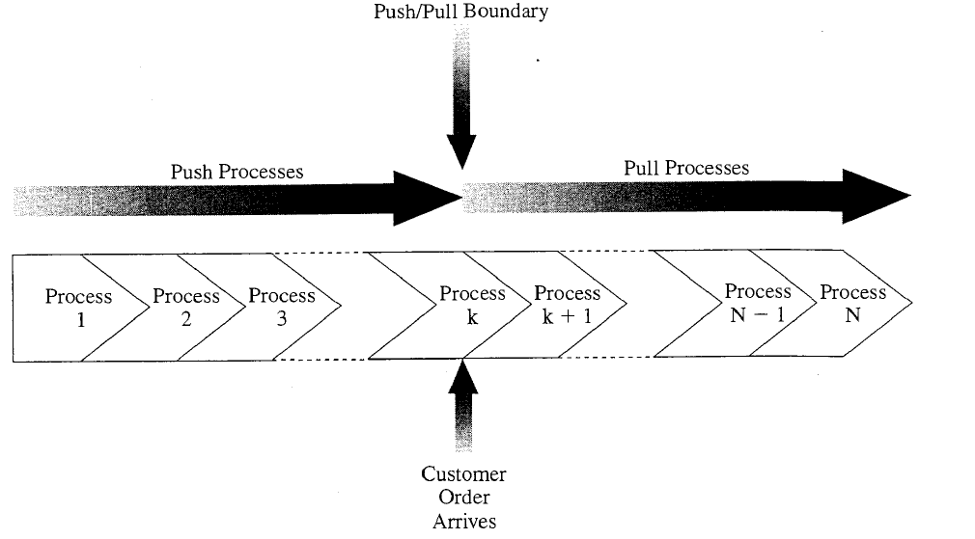

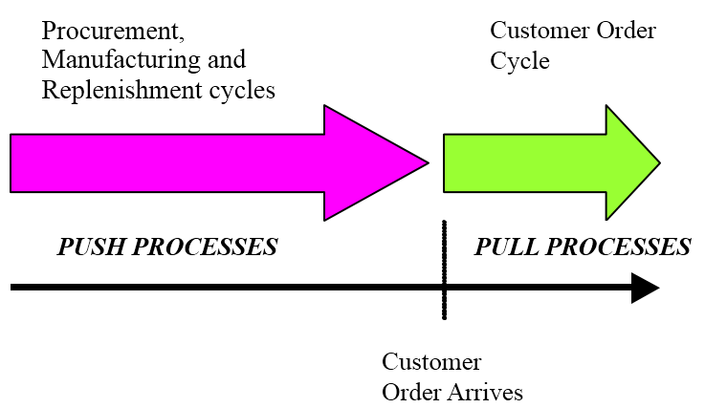

**Figure 2**

**Push/pull view of LL beans supply chain**

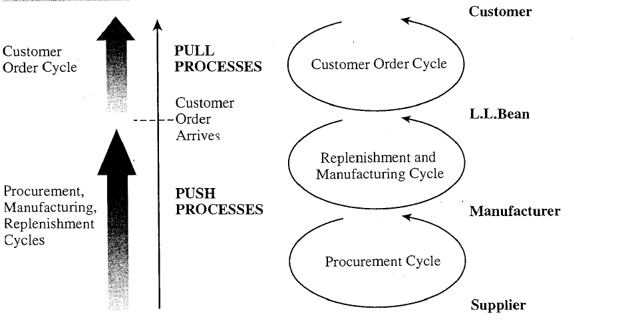

**Figure 3**

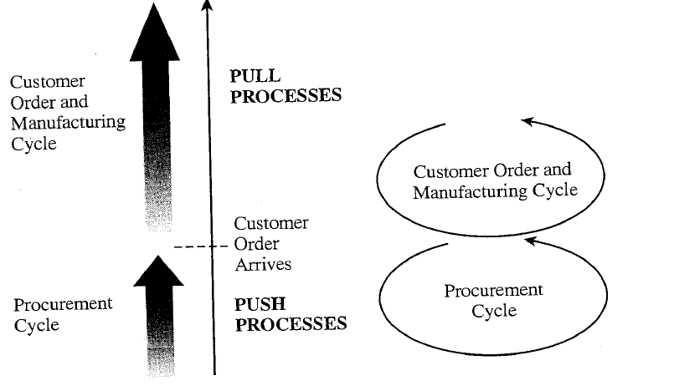

All processes in the customer order and manufacturing cycle at Dell are thus classified as pull processes because they are initiated by customer arrival. Dell, however, does not place component orders in response to a customer order. Inventory is replenished in anticipation of customer demand. All processes in the procurement cycle for Dell are thus classified as push processes, because they are in response to a forecast. The processes in the Dell supply chain break up into pull and push processes as shown in Figure 3.

A push/pull view of the supply chain is very useful when considering strategic decisions relating to supply chain design. The goal is to identify an appropriate push/pull boundary such that the supply chain can match supply and demand effectively.

## 5.3 Bullwhip Effect in Supply Chain

Bullwhip effect is the uncertainty caused by information flowing upstream and downstream in the supply chain. In particular, forecast of demand become less reliable as they move up the supply chain from users or retailers to whole-sellers, to manufacturers, to suppliers. Conversely, the forecast of demand variability, through present, lessons as point of forecast moves downstream.

**Information Distortion in Supply Chain -The Bullwhip Effect**

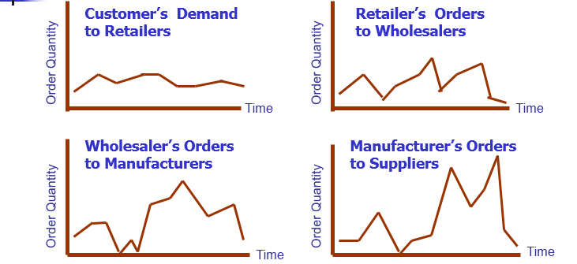

Bullwhip Effect: The increasing variability in demand orders from downstream customers to upstream suppliers.

**5.3.1 Causes of Bullwhip effect**

The most common drivers of demand distortion are:

* Un-forecasted sales promotion, which have a ripple effect throughout the supply chain
* Sales incentive plans when executed to, say, 3 months often results to sale distortion
* Lack of customer confidence in the ability of suppliers to deliver orders on time, leading to over ordering
* Cancellation of orders, often resulting from previous over ordering
* Freight, such as transportation discounts for volume order, that may cause customers to accumulate orders and then order in bulk.
* Uncertainty at every stage of supply chain
* Lack of information sharing and coordination among supply chain members

**5.3.2 Consequences of Bullwhip effect**

* Excessive inventory quantities
* Poor customer services
* Cash flow problems
* Stock outs
* High material cost, overtime expenses and transport costs.
* Poor demand forecasts
* Insufficient or excessive capacities
* Inefficiency and/or irresponsiveness in the supply chain operations